**Lab04: Perform Active Reconnaissance with Windows**

1. Follow the instructions from section **1 Use PowerShell to Perform an Active Reconnaissance of a Windows Server.**
   1. Submit a screenshot of the results from step 8.

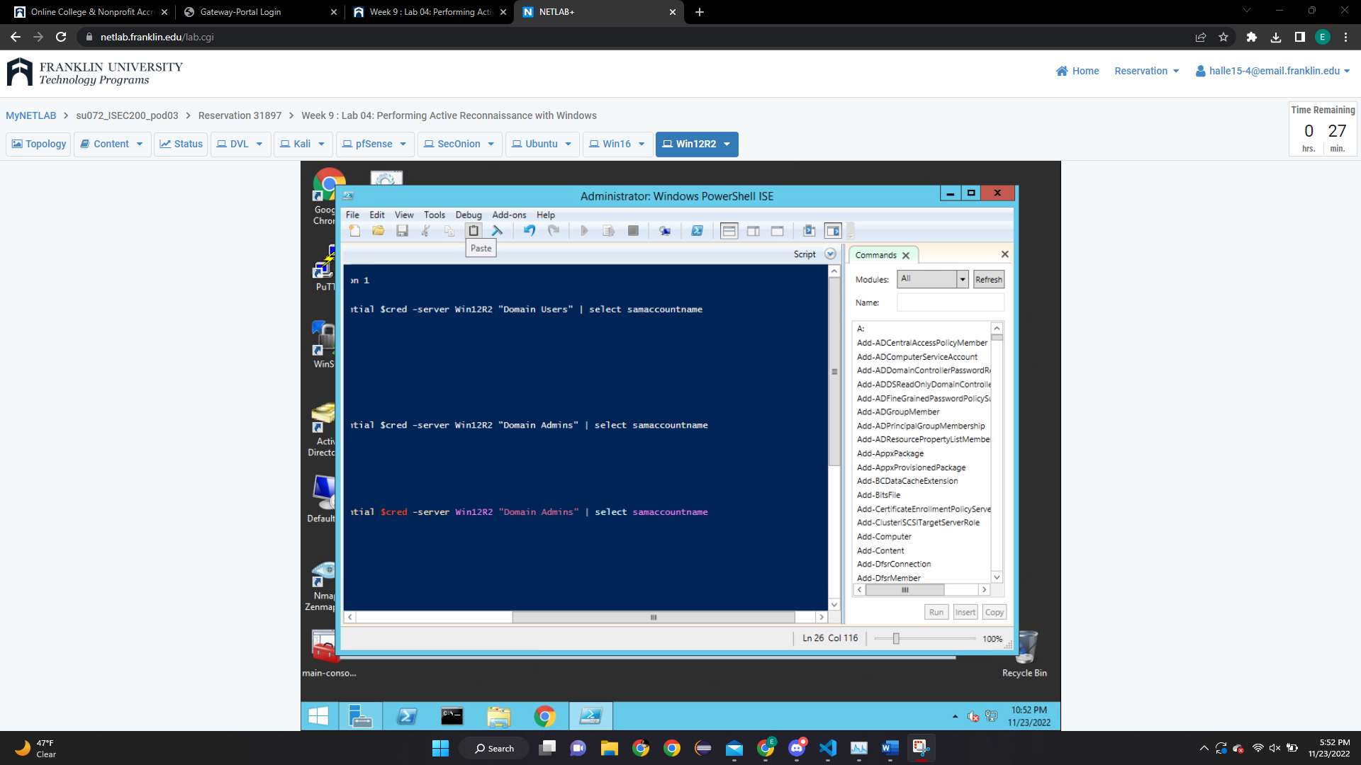

* 1. Submit a screenshot of the results from step 13.

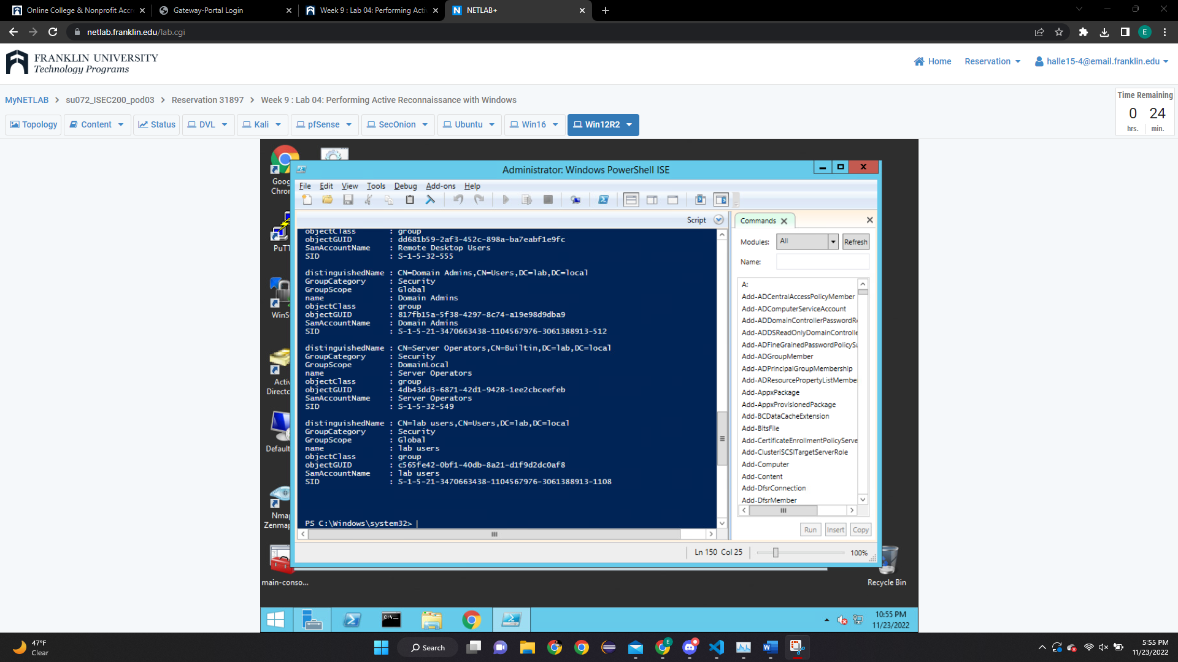

1. Follow the instructions from section **2 Use PowerShell to Perform an Active Reconnaissance of a Windows Client.**
2. Submit a screenshot of the results from step 1.

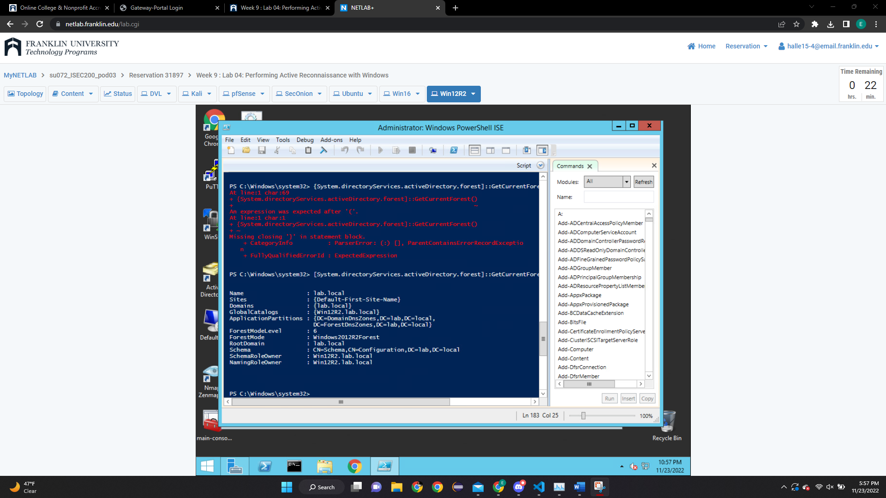

1. Submit a screenshot of the results from step 2.

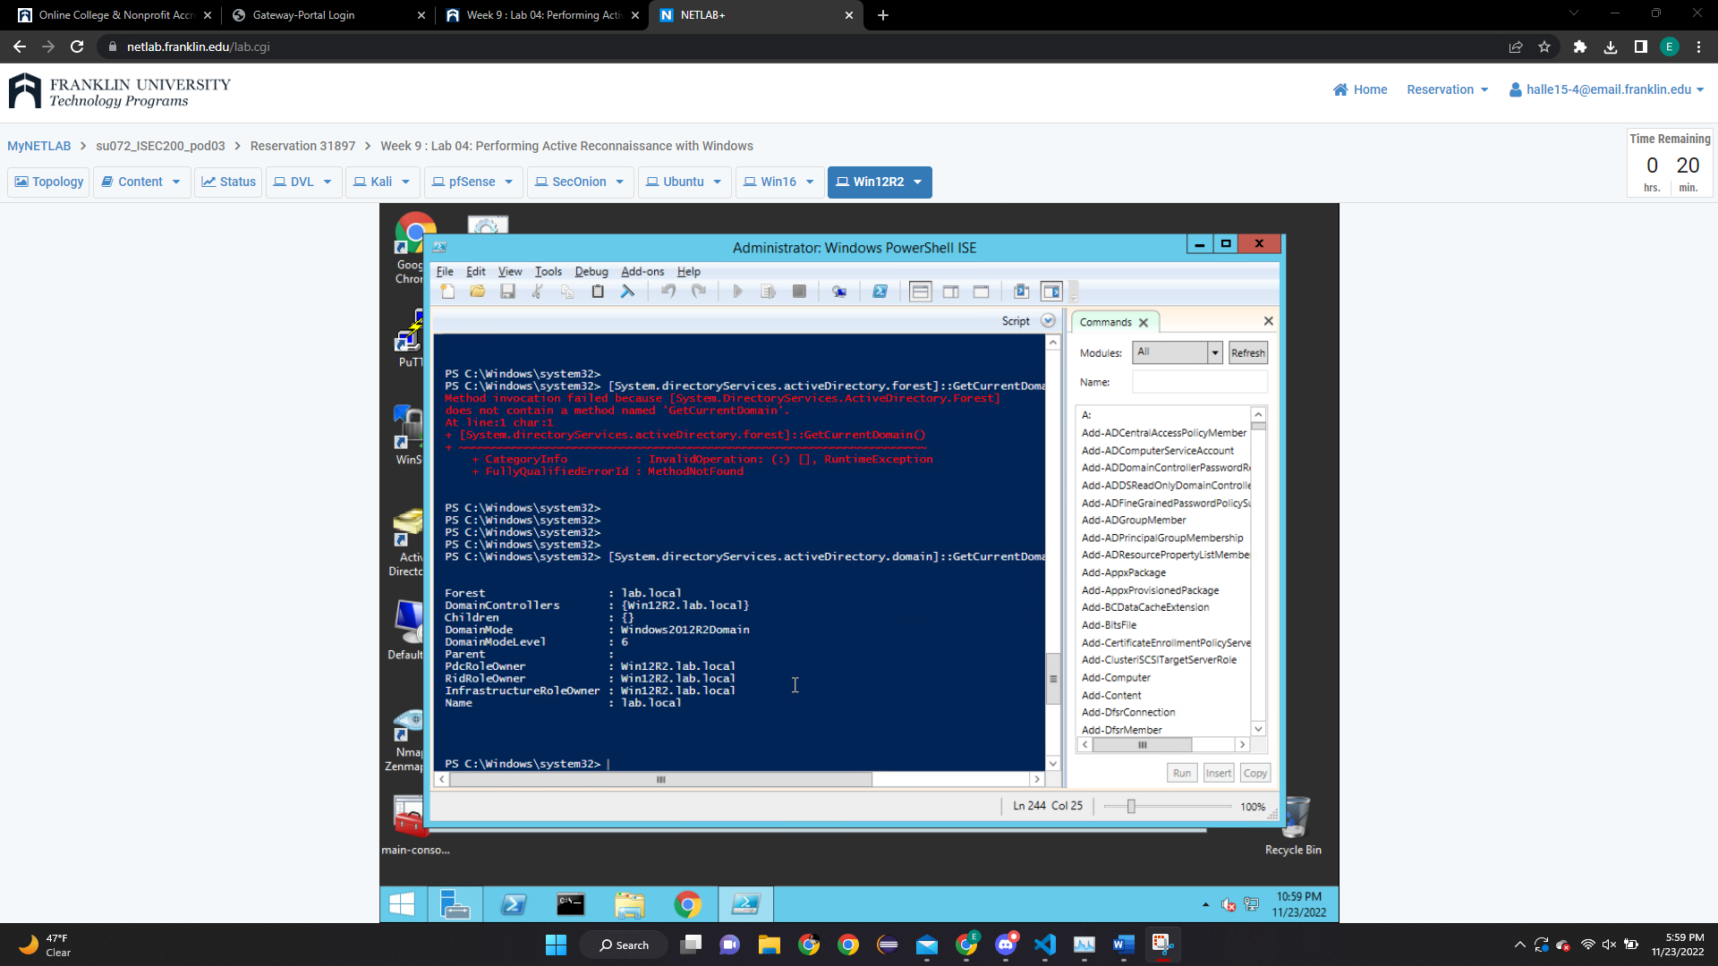**Analysis Questions**

1. What is **PowerShell? – a wrapper to the underlying command line with additional scripting language capabilities.**

1. Is Windows **PowerShell** the same as **command prompt**? – it isn’t, the cmd prompt is ap art of the powershell.

**Lab05: Perform Active Reconnaissance with Linux**

1. Follow the instructions from section **1.1 Scanning the Network for Using Nmap**
   1. Submit a screenshot of the results from step 12.

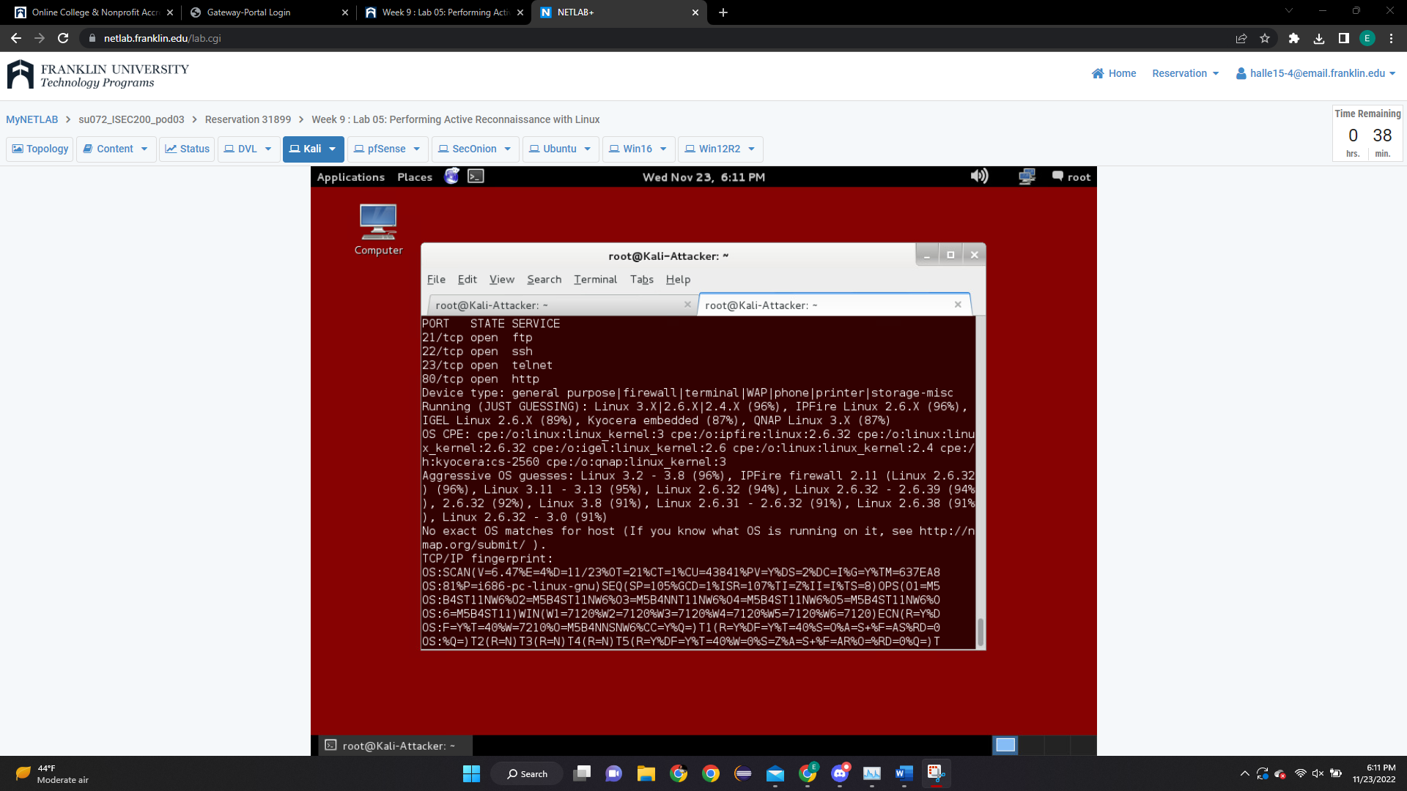

* 1. Submit a screenshot of the results from step 19.

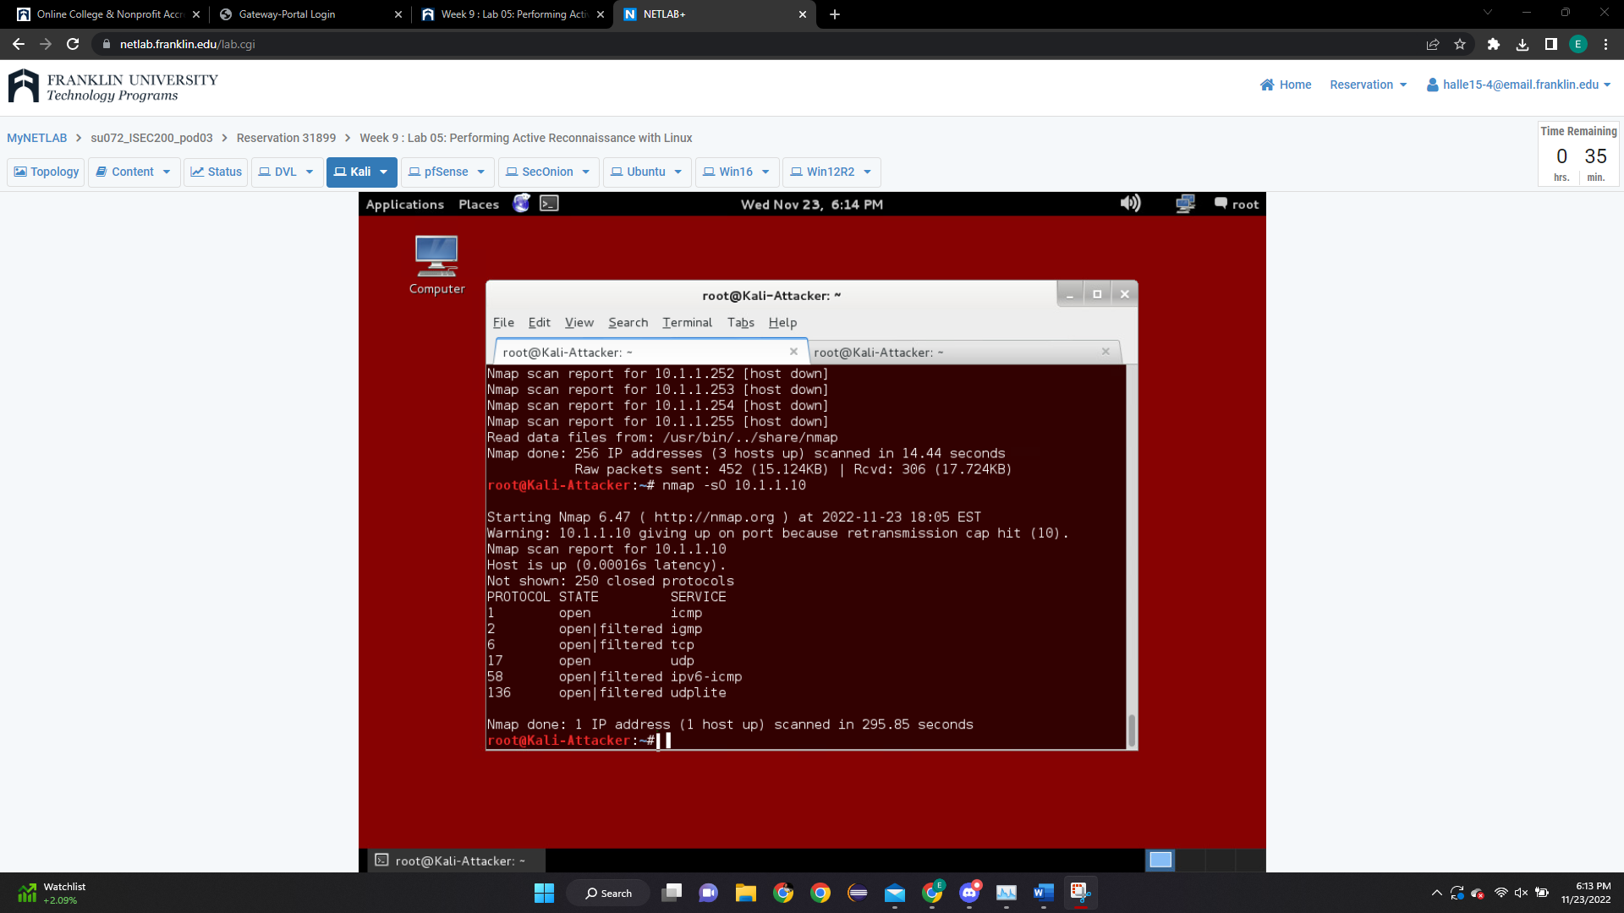

1. Follow the instructions from section **1.2 Scanning the Network for Using Zenmap**
   1. Submit a screenshot of the results from step 4.

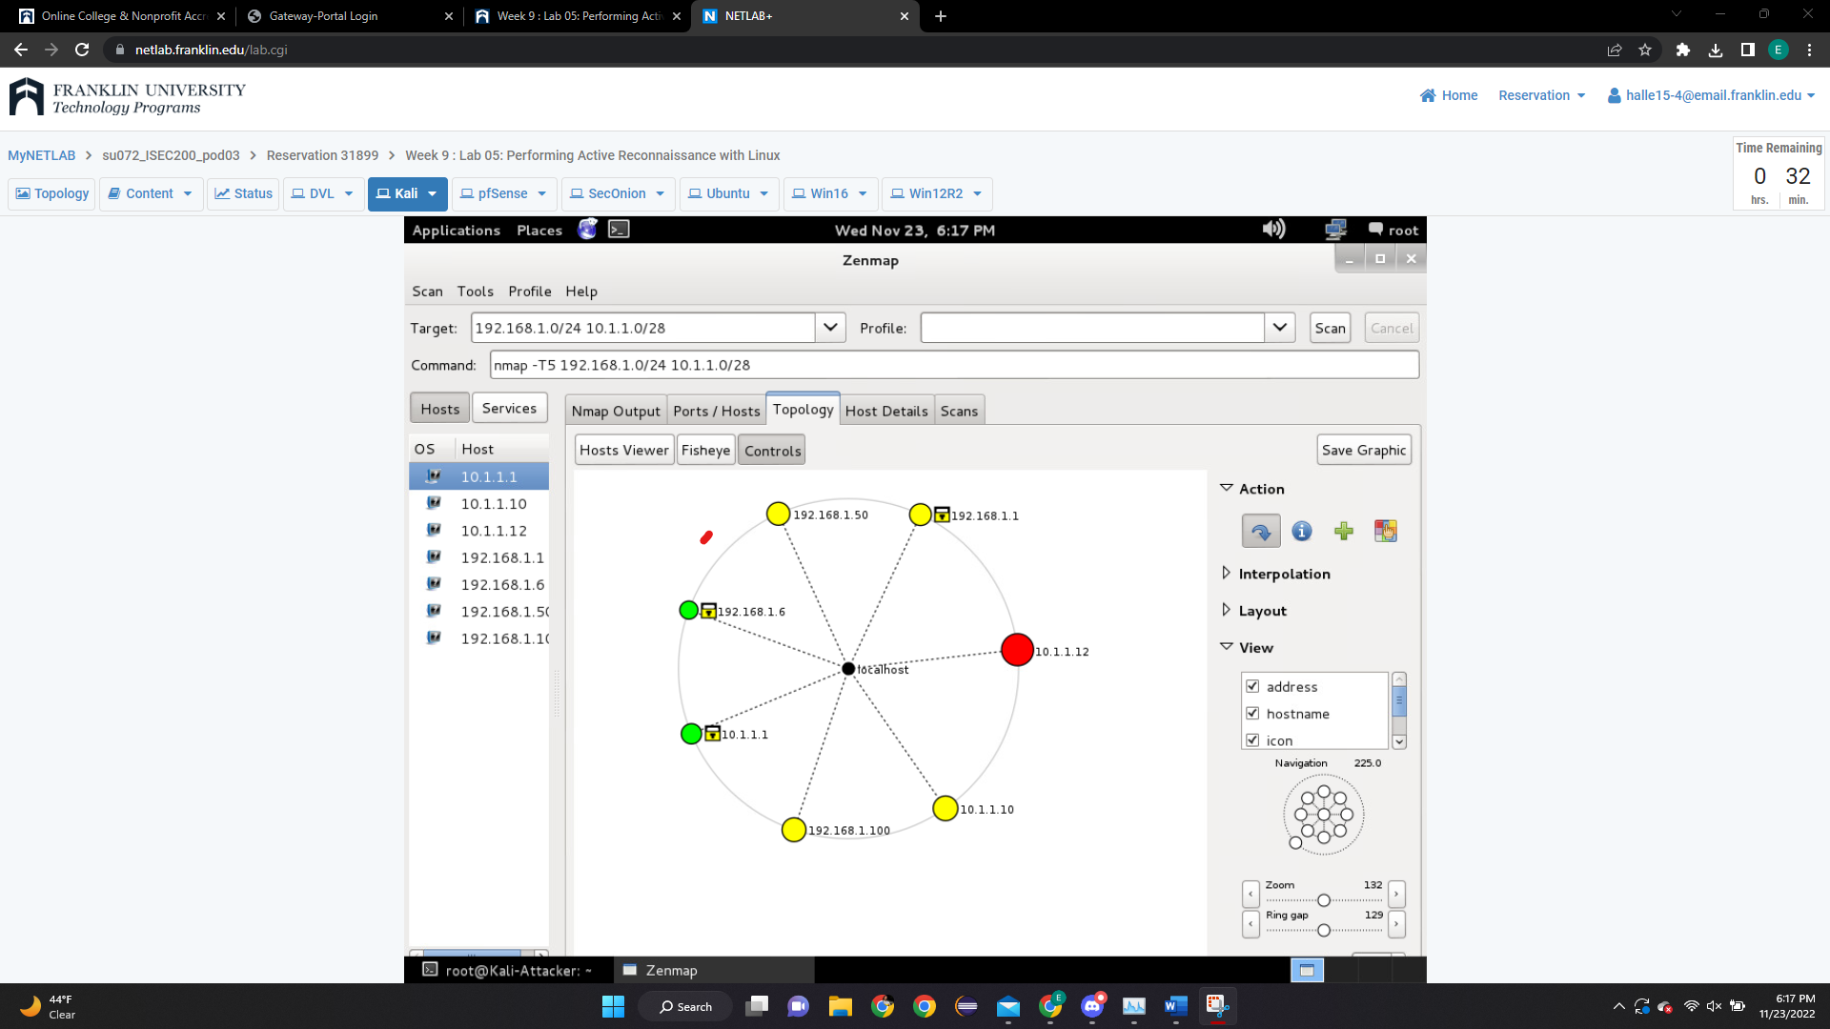**SCREENSHOT**

**HERE**

1. Submit a screenshot of the results from step 9.

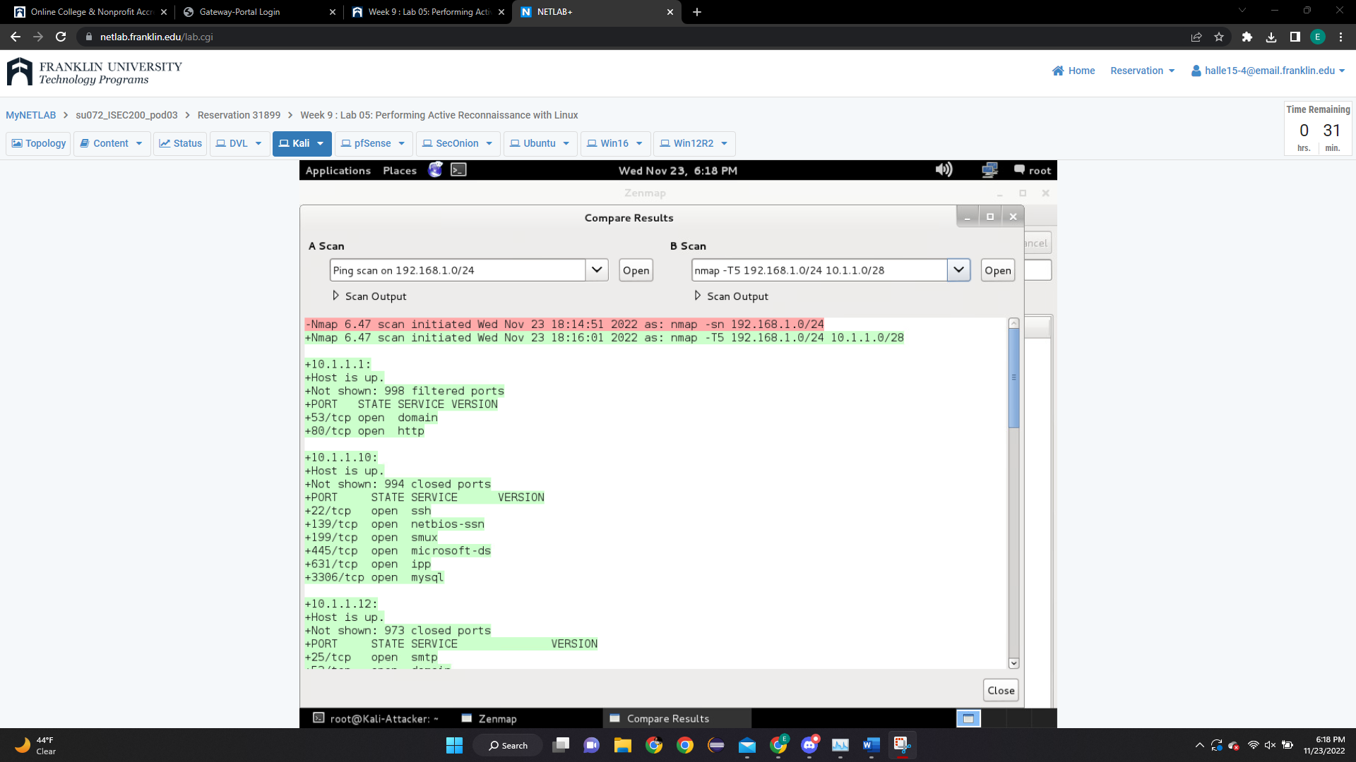

1. Follow the instructions from section **2.1 Scanning with OpenVAS**

**Note:**  You might have to repeat step 1 through 3 of section 2.1 couple times in order to get step 6 to work.

* 1. Submit a screenshot of the results from step 10.

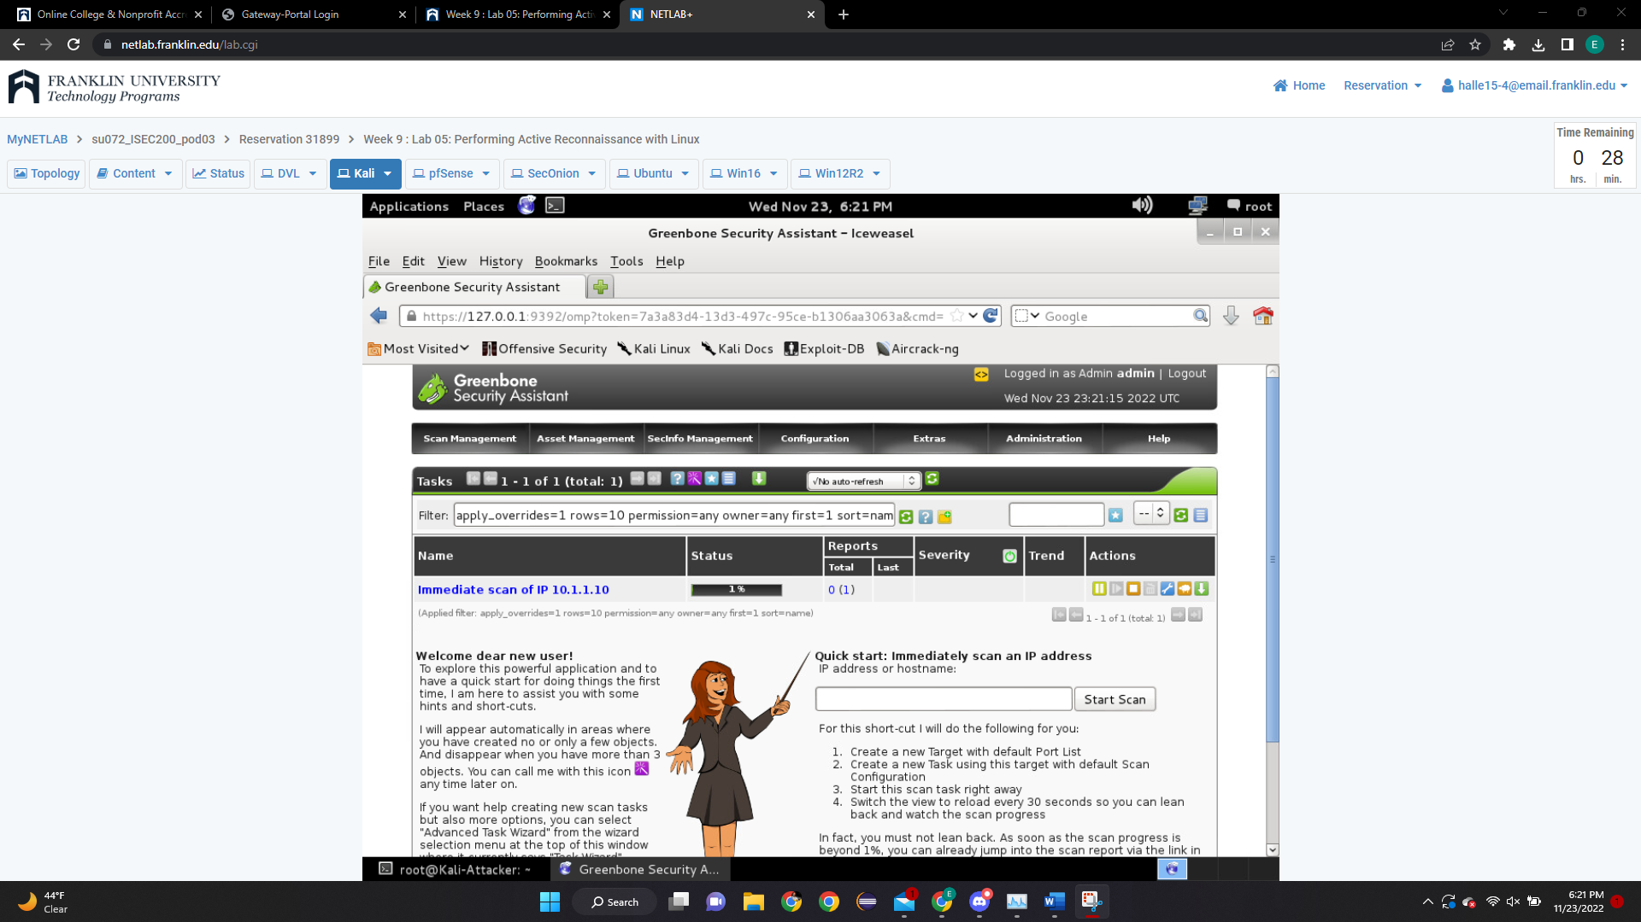

1. Submit a screenshot of the results from step 12.

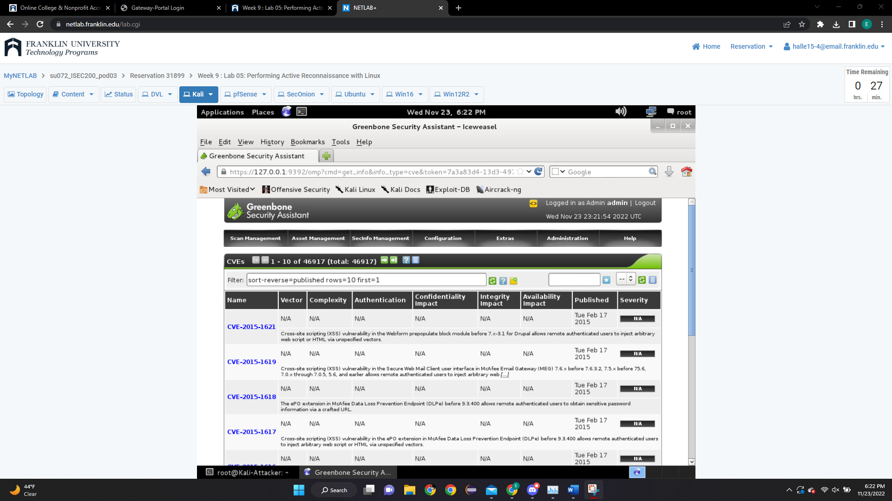

1. Follow the instructions from section **2.2 Create New Target**
   1. Submit a screenshot of the results from step 6.

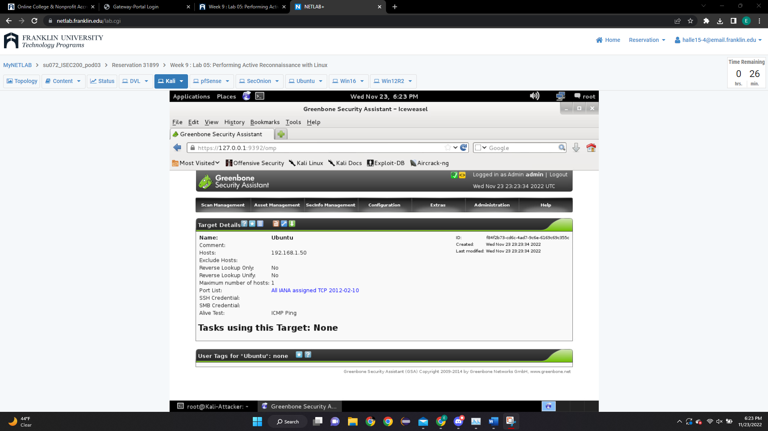

1. Submit a screenshot of the results from step 7.

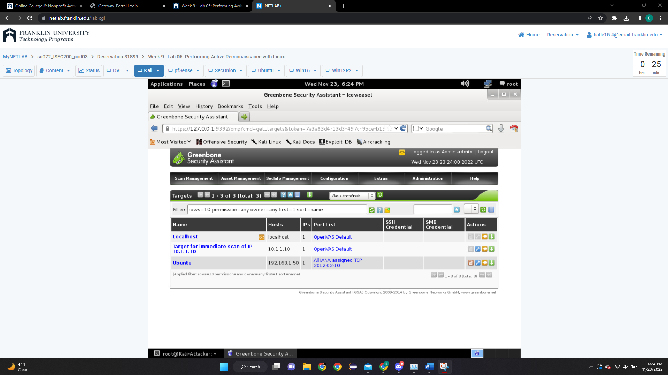

1. Follow the instructions from section **2.3 Create New User**
   1. Submit a screenshot of the results from step 3.

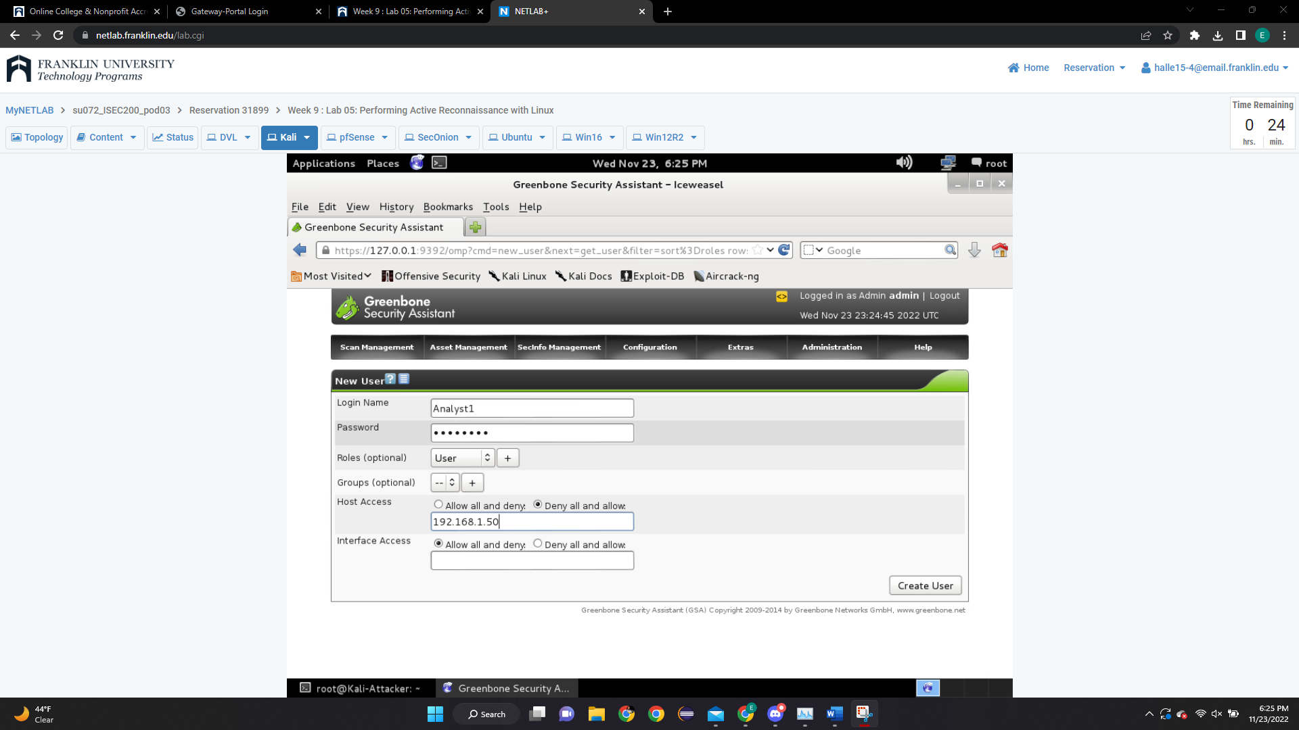

1. Submit a screenshot of the results from step 4.

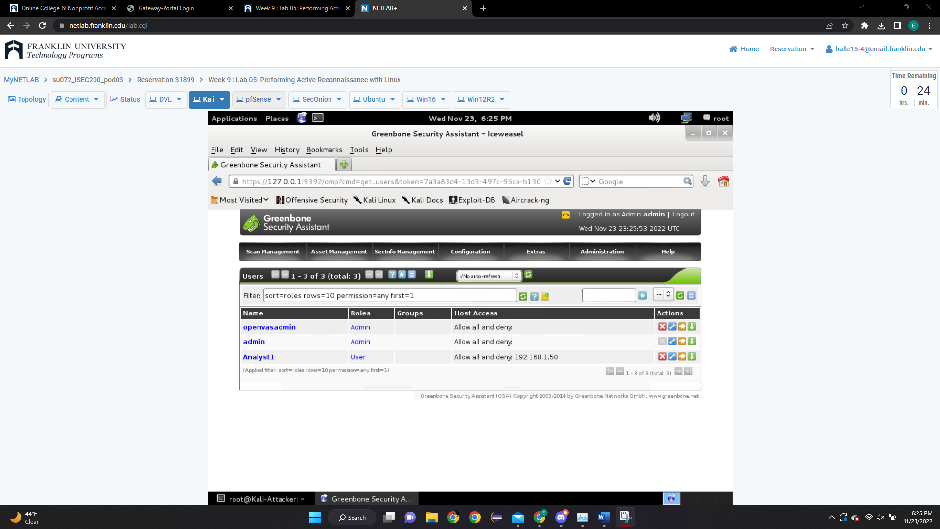

1. Follow the instructions from section **2.4 Create New Schedule**
   1. Submit a screenshot of the results from step 3.

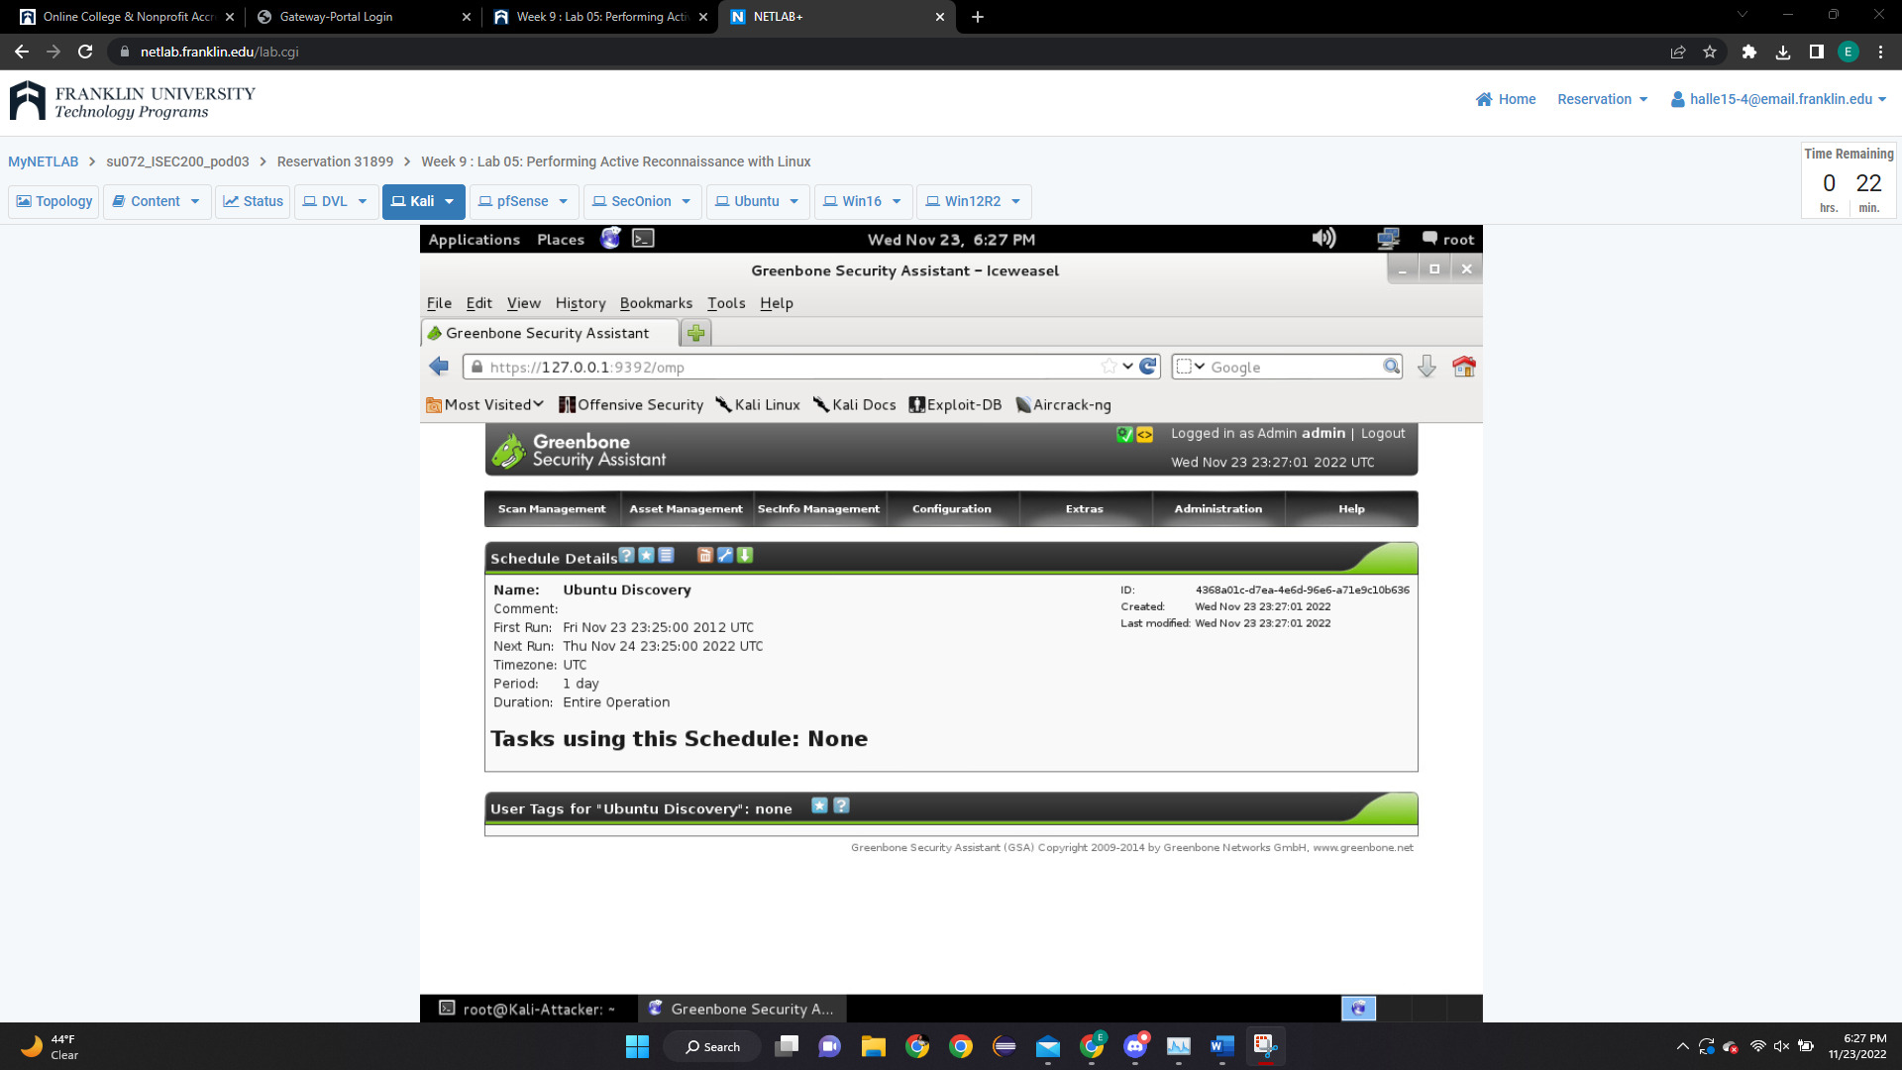

1. Submit a screenshot of the results from step 4.



1. Follow the instructions from section **2.5 Schedule New Task**
   1. Submit a screenshot of the results from step 3.

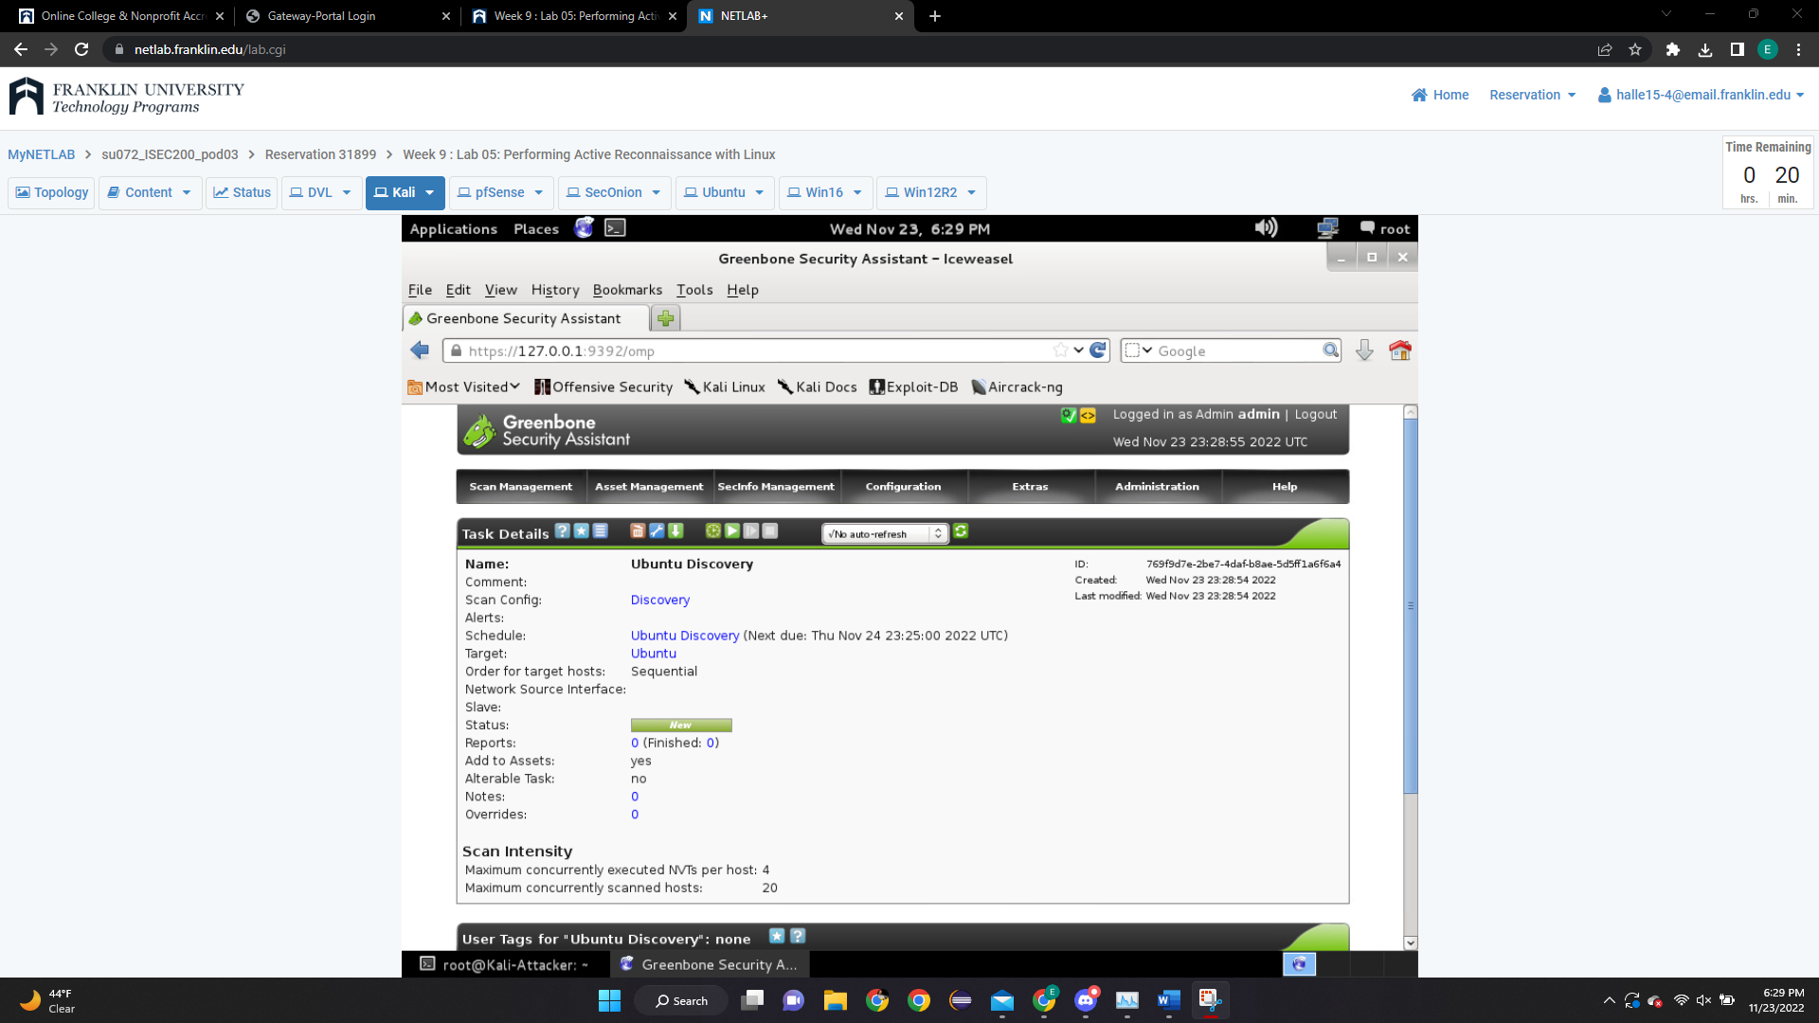

1. Submit a screenshot of the results from step 4.

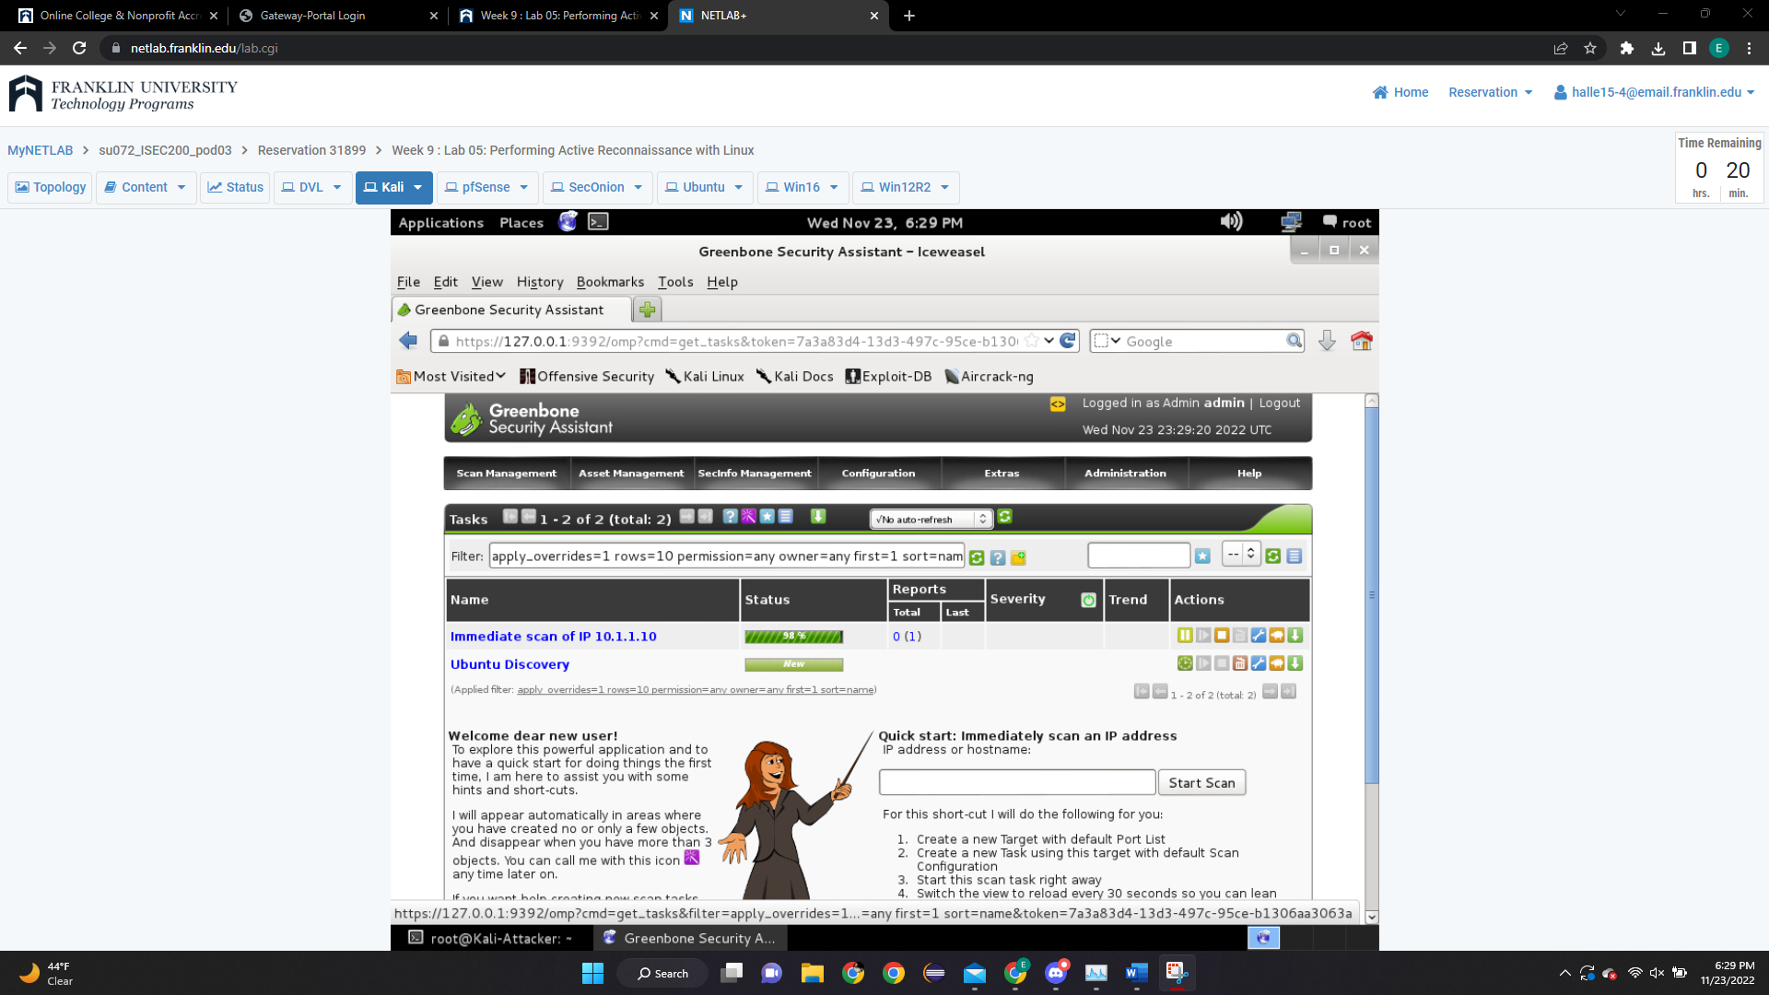

1. Follow the instructions from section **2.6 Analyzing the Scan Report**
   1. Submit a screenshot of the results from step 2.

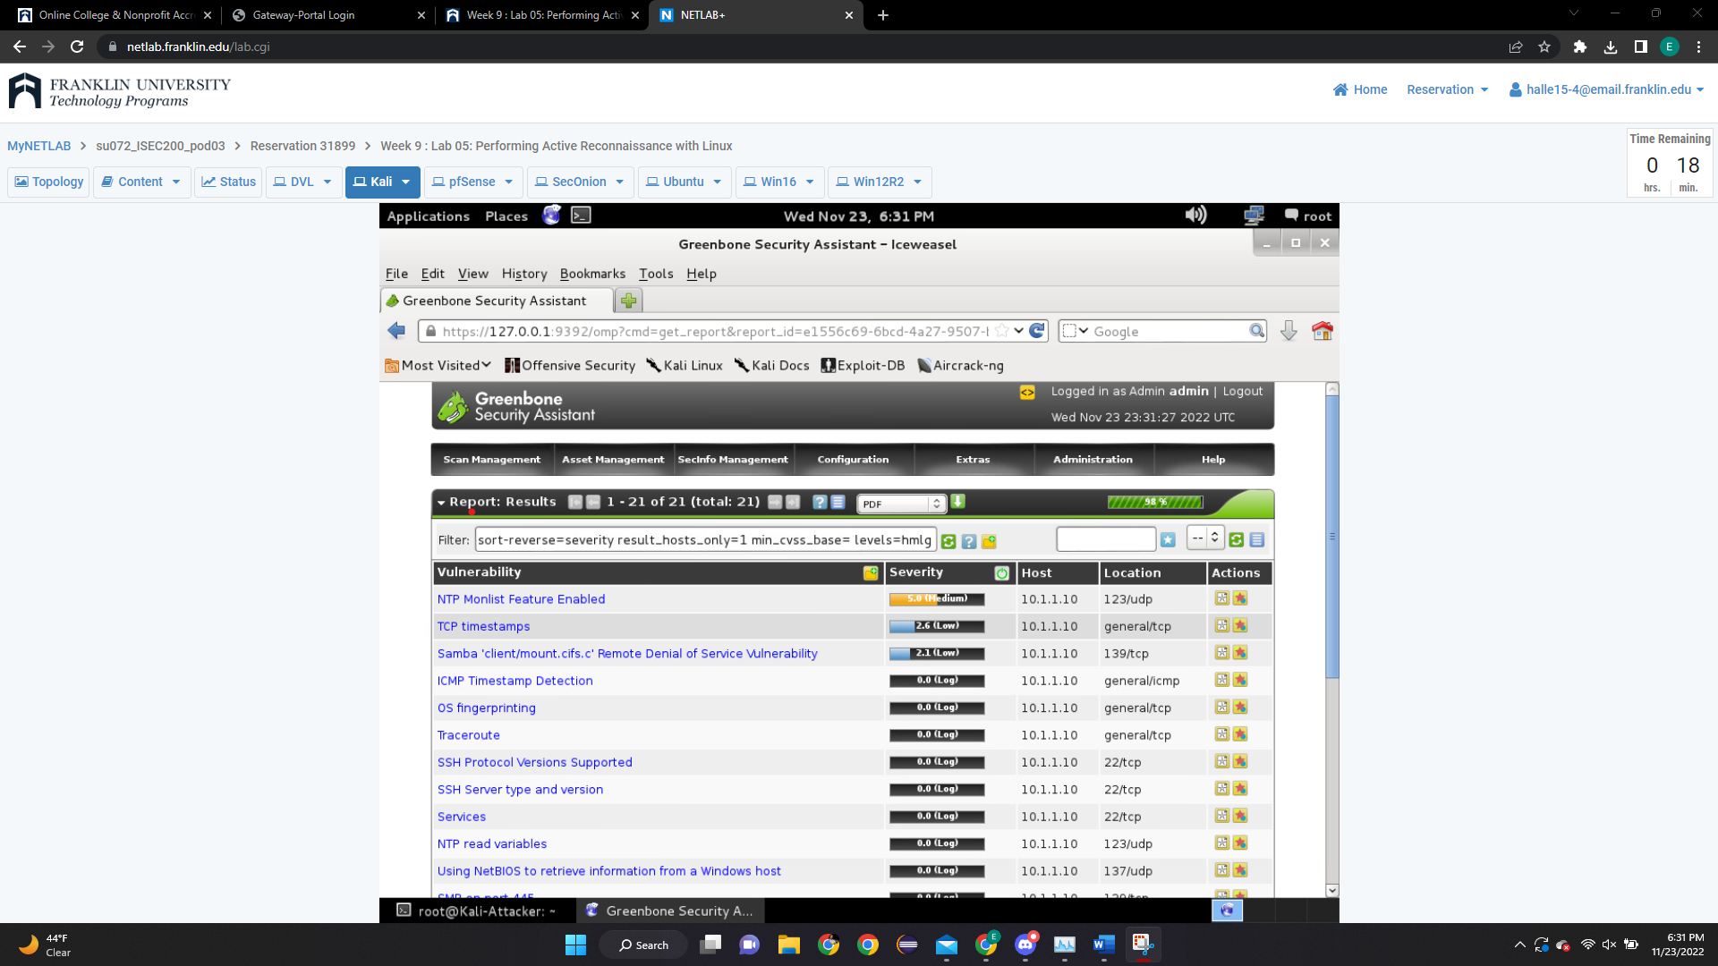

**Analysis Questions**

1. What is ping scan in nmap?

Nmap identifies all ip addresses that are online without actually sending data to those hosts.

1. Given a **TCP timestamps** vulnerability with summary and impact described below.

**Summary:** The remote host implements TCP timestamps and therefore allows to compute the uptime.

**Impact:** A side effect feature is that the uptime of the remote host can sometimes be computed.

Describe a possible method used to detect this vulnerability (hint: this is one the vulnerability listed on step 3 of section 2.6)?

There is an option in linux that allows users to remove tcp timestamps.